**WORLD ENERGY DATA OF THE YEAR 2019-2020**

**ERUPAKA ANJALI – S569064**

**INTRODUCTION TO MY PROJECT:**

This dataset offers a thorough analysis of the trends in energy usage for the years 2019 and 2020 from a variety of sources. The information contains specific numbers regarding the use of nuclear energy, renewable energy sources (such as solar, wind, hydro, and biomass), and fossil fuels (such as coal, oil, and natural gas). Significant changes in public views about sustainability and environmental effect, regulatory reforms, and technology developments have all occurred throughout this time. The information will make it easier to analyze how the world's energy environment has changed over time, highlighting the emergence of renewable energy sources and the fall of conventional fossil fuels while also offering predictions about future patterns in energy use.  
  
**DOMAIN OF MY DATASET:**

The domain of my dataset is energy consumption. It focuses on various energy sources and their usage over time, specifically in the years 2019 and 2020. This dataset is relevant to fields such as energy studies, environmental science, sustainability, and policy analysis. It encompasses data on fossil fuels, renewable energy sources, and nuclear energy, allowing for the analysis of trends, technological advancements, and shifts in public and policy attitudes towards different energy sources.

**BELOW IS THE LINK TO MY DATASET:**



**DATA SOURCE:**

The dataset was sourced from the Kaggle website.   
Data Source: [**https://www.kaggle.com/datasets/shub218/energy-data-1990-2020**](https://www.kaggle.com/datasets/shub218/energy-data-1990-2020)

**TABLEAU PUBLIC:**

Here is the link to my Tableau Public profile.

Tableau Public:[**https://public.tableau.com/app/profile/anjali.erupaka/vizzes**](https://public.tableau.com/app/profile/anjali.erupaka/vizzes) **RECORDS AND COLUMNS:**

* There are a total of 92 records.
* There are a total of 21 columns in my dataset.

**VIZUALIZATION TOOLS:**

I utilized PowerBI to design and develop visualizations and dashboards based on my dataset. You can access the PowerBI Dashboard through the provided link.



**DATA CLEANING STRATEGIES:**

I conducted data transformations exclusively within Power BI Desktop, without the need for any prior data cleaning. Although the dataset initially covered the years 1990 to 2020, I narrowed the focus to the years 2019 to 2020 for analysis and visualization purposes.  
  
**GOALS**:

Below are the objectives I've established to guide the creation of my charts or visualizations:

* **CO2 Emissions from fuel combustion (MtCO2) by country.**
* **Share of wind and solar electricity production of various regions**
* **Total Energy Production Vs Total Energy Consumption of different Regions.**
* **To demonstrate the Natural Gas production, Crude oil production and Coal and Lignite production across different Regions.**
* **Electricity Consumption of different Regions**
* **Production and consumption of Natural gas across different Regions.**
* **Crude oil production in different regions.**

**GOAL-1: CO2 EMISSIONS FROM FUEL COMBUSTION (MtCO2) BY COUNTRY.**

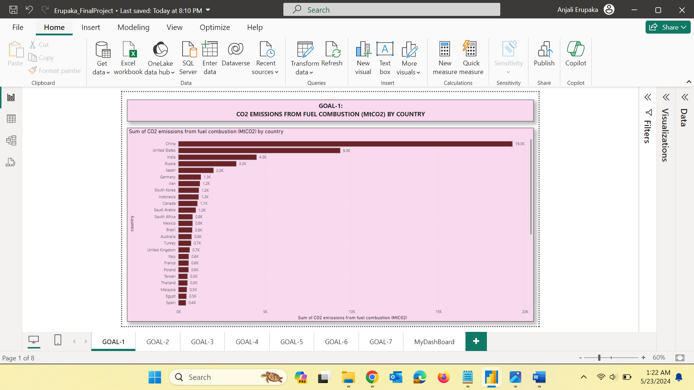

**Fig1: Bar graph for CO2 emissions of different countries**

**STORY: The chart provided presents a stark visualization of CO2 emissions from fuel combustion across various countries. The data is measured in megatonnes of CO2 (MtCO2), with countries ranked from the highest to the lowest emitters.** China tops the chart with a staggering 9.3K MtCO2 emissions, Countries like Germany, Iran, South Korea, and Indonesia each emit around 1.2K MtCO2, reflecting their industrial bases and energy policies

**GOAL-2:** **SHARE OF WIND AND SOLAR ELECTRICITY PRODUCTION OF VARIOUS REGIONS**

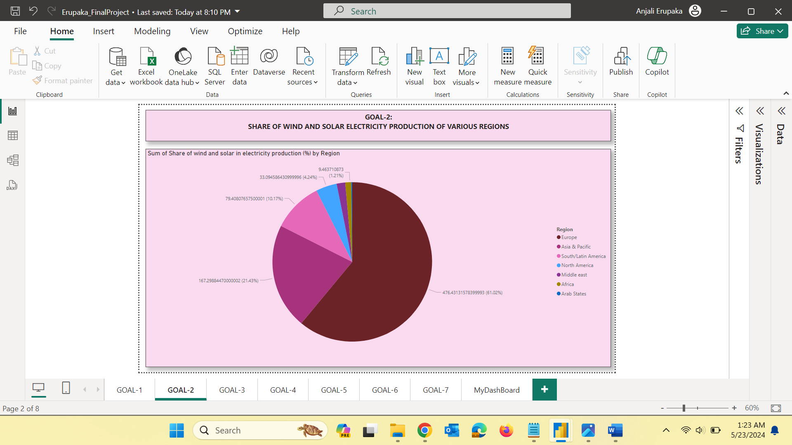

**Fig2: Pie Chart for the share of solar electricity**

**STORY:** The pie chart illustrates the distribution of wind and solar electricity production by region, offering insights into how different parts of the world are contributing to the renewable energy revolution. Europe emerges as the frontrunner, accounting for a significant 61.02% of the global share in wind and solar electricity production.These regions collectively represent smaller shares (Middle East: 1.21%, Africa: less significant share visible, Arab States: minimal share).

**GOAL-3: TOTAL ENERGY PRODUCTION VS TOTAL ENERGY CONSUMPTION OF DIFFERENT REGIONS**

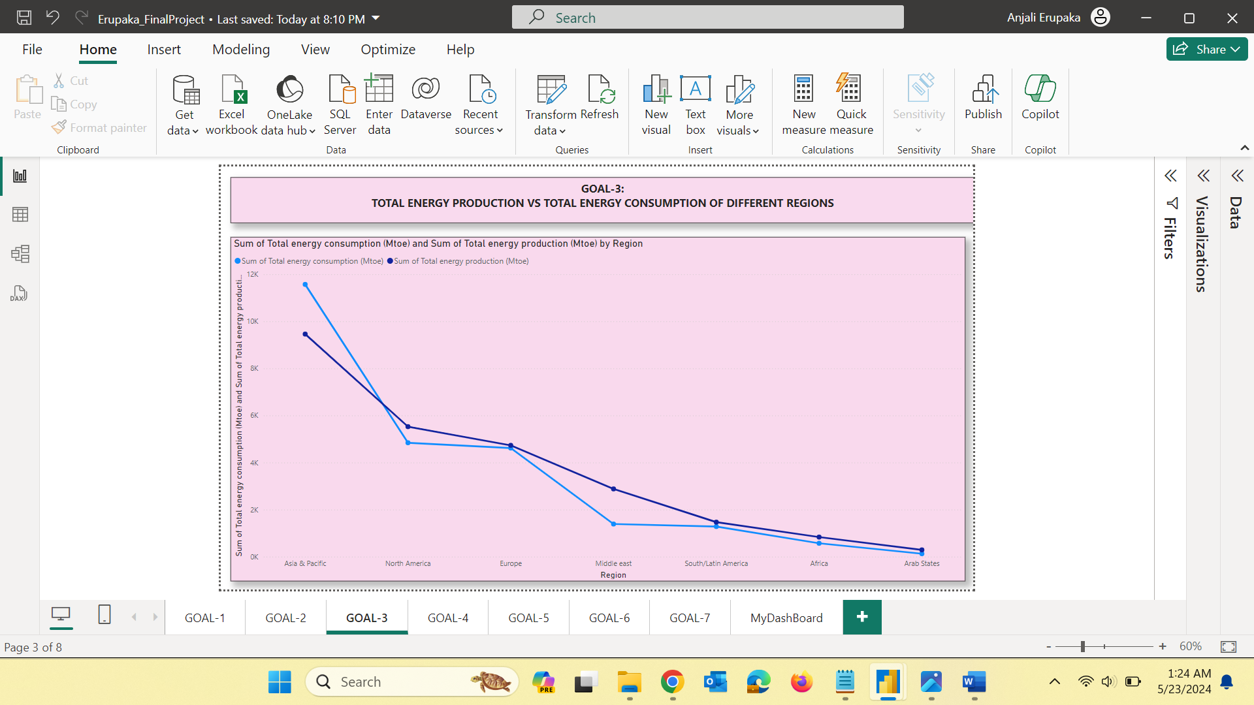  
**Fig3: Line Chart for total energy production vs consumption**

**STORY:** The provided line chart compares the total energy production and consumption across different regions. The data is measured in million tonnes of oil equivalent (Mtoe), giving a clear picture of energy dynamics globally. The Asia & Pacific region exhibits the highest levels of both energy production and consumption, with consumption slightly surpassing production. The Arab States, similar to the Middle East, produce more energy than they consume.

**GOAL-4:** **TO DEMONSTRATE THE NATURAL GAS PRODUCTION, CRUDE OIL PRODUCTION AND LIGNITE AND COAL PRODUCTION ACROSS DIFFERENT REGIONS.**

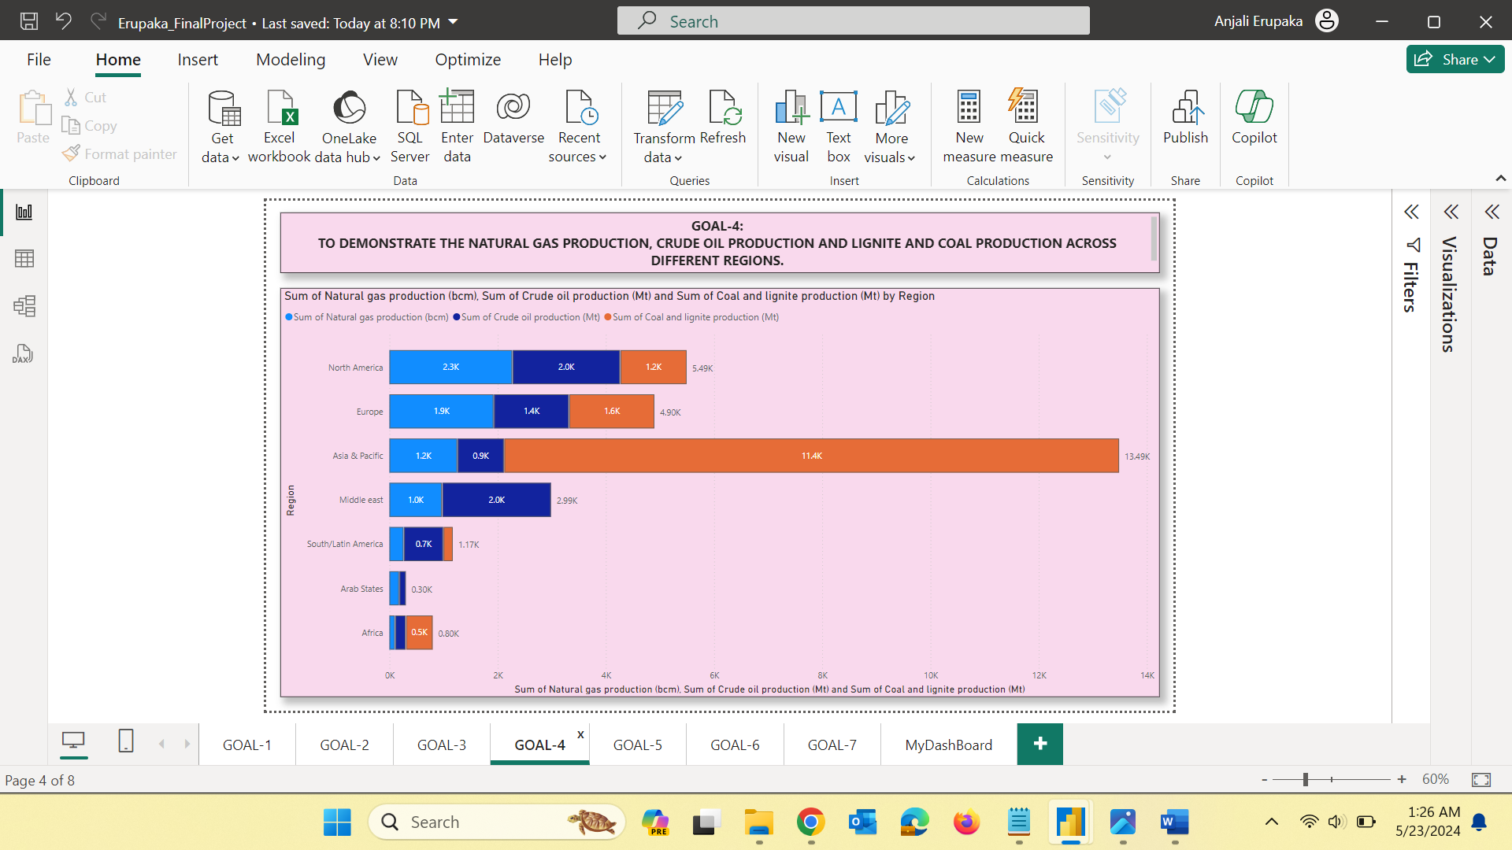

**Fig4: Stacked Bar Chart for different source of energy productions**

**STORY:** Asia and the Pacific lead in producing natural gas, crude oil, and coal, driven by their large reserves and industrial demands. In contrast, the Arab Emirates focus mainly on crude oil, producing less natural gas and almost no coal. This highlight regional differences in resource availability and energy strategies.

**GOAL-5:** **ELECTRICITY CONSUMPTION OF DIFFERENT COUNTRIES**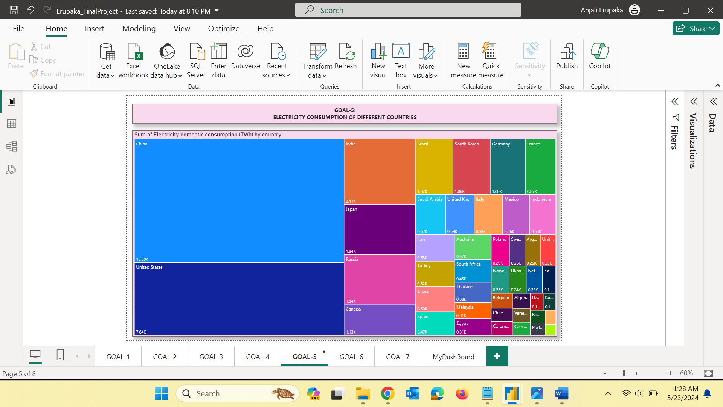

**Fig5: Tree Map for electricity consumption**

**STORY:** The tree map visualization of electricity consumption reveals significant disparities among countries, highlighting their unique energy demands and consumption habits. United States and China are at the forefront of electricity consumption, driven by their massive industrial bases, high population densities, and advanced technological sectors. Many developing nations display lower electricity consumption. This is often due to limited infrastructure, lower industrial activity, and restricted access to electricity in rural areas.

**GOAL-6:** **PRODUCTION AND CONSUMPTION OF NATURAL GAS ACROSS DIFFERENT REGIONS**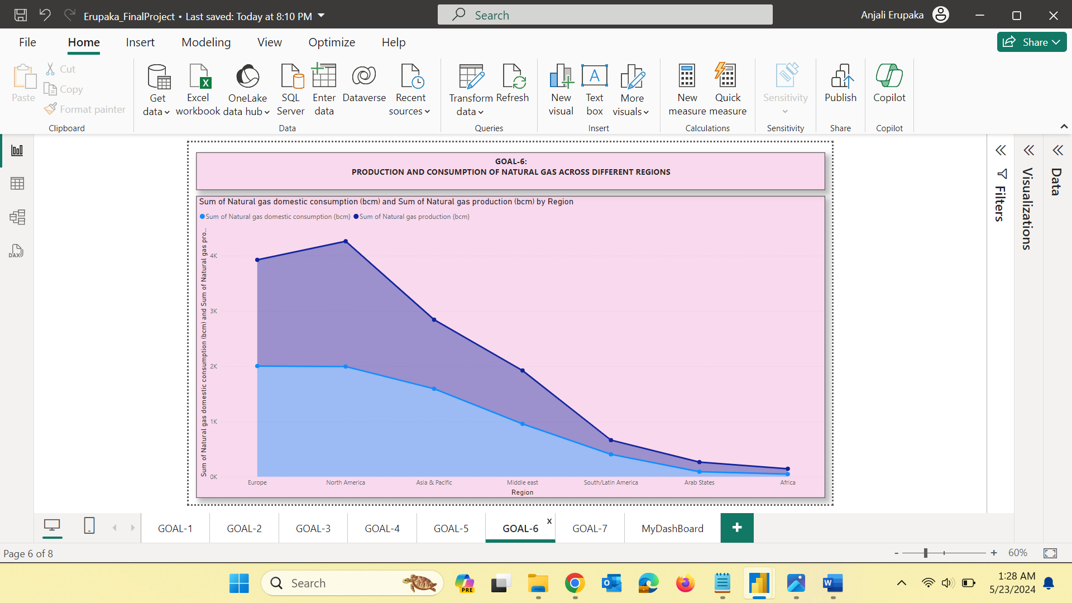

**Fig6: Area Chart for production & consumption of natural gas**

**STORY:** The analysis reveals significant differences in how regions produce and consume natural gas, reflecting their energy strategies, resources, and economic activities. The patterns of natural gas production and consumption across different regions highlight diverse energy landscapes and strategic priorities. Balancing production with consumption is crucial for ensuring energy security, economic stability, and sustainable development.

**GOAL-7:** **CRUDE OIL PRODUCTION IN DIFFERENT REGIONS**

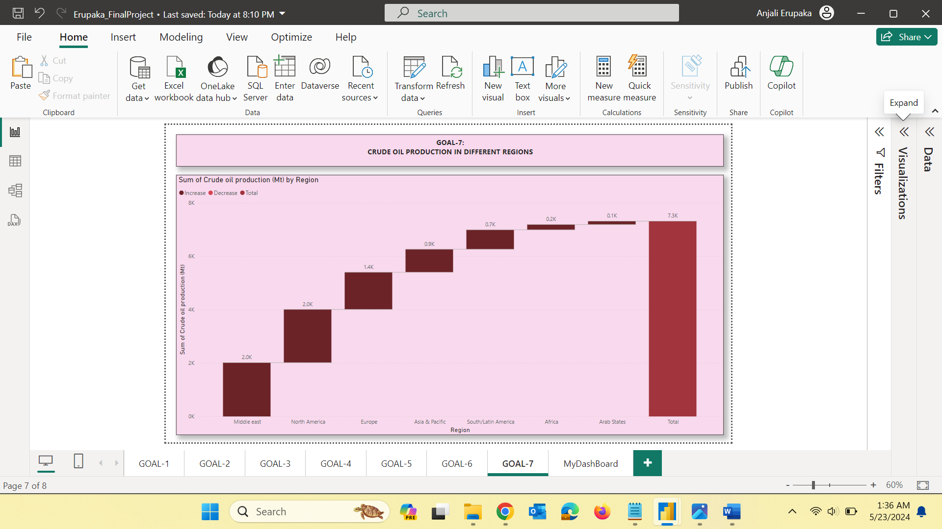

**Fig7: Waterfall chart for crude oil production**

**STORY:** The analysis reveals distinct regional disparities in crude oil production, influenced by geological, technological, and economic factors. Crude oil production varies significantly across regions, shaped by natural resources, technological advancements, and economic conditions. Understanding these patterns helps in comprehending the global oil market dynamics and informs strategic energy policies.

**MY DASHBOARD:**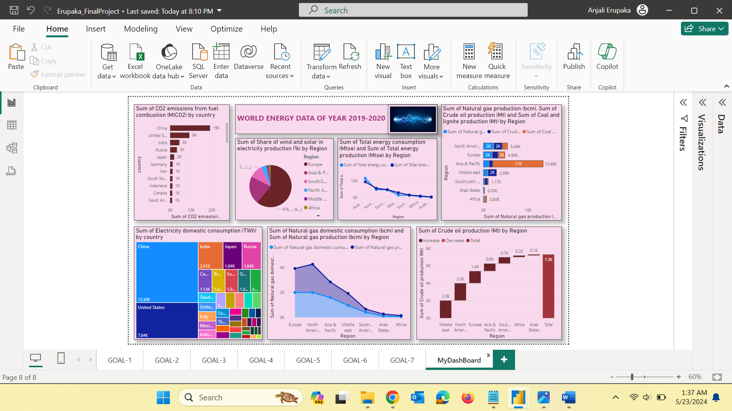  
Fig8: DashBoard for the dataset

**CONCLUSION:**  
  
The comprehensive analysis of global energy data reveals intricate interplays between production, consumption, and regional dynamics. While certain regions like Asia-Pacific emerge as energy powerhouses with high consumption and production across various resources, others, like the Middle East and North America, maintain dominance in specific sectors like crude oil and natural gas, respectively. Understanding these patterns is crucial for formulating sustainable energy policies that balance economic growth with environmental conservation and energy security on a global scale.

*** THE END ***